




សាកលវិទ្យាល័យភ្នំពេញអន្តរជាតិ
PHONM PENH INTERNATIONAL UNIVERSITY

Topic: UrbanCart Big Data Analytics
កិច្ចការស្រាវជ្រាវនិសិ្សតថ្នាក់បរិញ្ញាបត្រ
ឯកទេស៖ Big Data Analytics
សាស្រ្តាចារ្យ៖ Min Sothearith
ក្រុមទី៖ ០៩
សមាជិកក្រុម ៖
Keo Samnang ID: CSE2024220051
Sue Theara ID: MIS2024220028
Teng Nyka ID: CSE2024220010

ឆ្នាំសិក្សា៖ ២០២៦

Table of Contents

- Executive Summary
- Introduction and Business Context
- Data Description
- SQL Extraction and Methodology
- Data Cleaning and Integration
- NumPy Analytical Methods
- Findings and Business Insights
- Limitations and Threats to Validity
- Recommendations and Next Steps
- Reusable Pipeline
- Appendix A - SQL Listing
- Appendix B - Data Dictionary and Contribution Statement

Executive Summary
UrbanCart's cleaned completed-order transactions generated net revenue across six categories. Books & Media was the strongest category at $2,288,541.26, while the leading customer spent $145,169.05. The strongest RFM segment was Champions, contributing $2,455,158.51. The supplier reconciliation identified 12 supplier-only products and 45 database-only products.
The Normal Equation regression achieved R-squared 0.680. It projected revenue of $334,584.22 and $339,289.52 for the next two months. The review-rating/repeat-purchase correlation was 0.035, indicating that ratings alone provide little explanatory power for customer loyalty.

Top five findings
- Books & Media generated the highest category revenue.
- Champions customers generated the largest RFM-segment revenue.
- Beauty & Health had the highest return-unit rate at 2.45%.
- The supplier catalog contained 12 supplier-only SKUs and the database contained 45 database-only products.
- Rating and repeat-purchase correlation was weak (0.035).

Priority recommendations
- Protect availability for the strongest categories and highest-revenue products.
- Target Champions and high-value churn-risk customers with differentiated retention campaigns.
- Investigate product quality and content accuracy in high-return categories.
- Create a governed product-master process to reconcile internal and supplier catalogs.
- Use the revenue forecast as a planning range rather than a guaranteed point estimate.

1. Introduction and Business Context
UrbanCart is a fictional online retailer operating across fifteen cities and six product categories. Leadership requires an evidence-based view of customer value, product profitability, demand, and data quality. The project builds a complete pipeline from raw operational data and messy external files to reusable tables, NumPy models, charts, and management recommendations.

1.1 Business questions
- Who are UrbanCart's most valuable customers, and what indicates loyalty or churn?
- Which products and categories remain profitable after discounts, costs, and returns, and what is the near-term demand outlook?
- Can the marketing and supplier data be trusted, and what controls are needed to improve it?

1.2 Analytical approach
Phase 1 extracts decision-ready results with SQL. Phase 2 cleans and reconciles data with pandas. Phase 3 demonstrates underlying numerical methods directly with NumPy. Phase 4 converts model output into eight business insights, while Phase 5 packages the workflow so it can be rerun with one command.

2. Data Description
The operational SQLite database contains customers, products, orders, order_items, reviews, and web_sessions. Two external spreadsheets represent a legacy marketing export and a supplier catalog. The source data intentionally contains missing values, duplicate or near-duplicate records, inconsistent date formats, invalid ratings, extreme prices, and partially overlapping product coverage.
Dataset | Purpose | Clean rows
customers | Customer identity and demographics | 2500
products | Product master and price/cost | 312
orders | Order headers and payment status | 9000
order_items | Product-level transactions and returns | 20176
reviews | Ratings and review text | 4000
web_sessions | Engagement by device | 12000

2.1 Known data limitations
- Missing age, city, gender, and review text require field-specific policies.
- Returns are represented by negative quantities rather than a separate returns table.
- Supplier and database products have incomplete overlap.
- Forecasting is based on a limited historical window and assumes recent relationships continue.

3. SQL Extraction and Methodology
All ten SQL queries are stored in queries.sql and are run directly against ecommerce.db. Results are loaded into pandas and exported to outputs/tables.
3.1 Query 1 - Category revenue and average order value
category | total_revenue | total_orders | average_order_value
Books & Media | 2,288,541.26 | 1649 | 1,387.84
Beauty & Health | 1,781,007.78 | 1637 | 1,087.97
Apparel | 967,057.00 | 1629 | 593.65
Sports & Outdoors | 916,247.78 | 1579 | 580.27
Electronics | 900,204.48 | 1615 | 557.40
Home & Kitchen | 781,563.91 | 1660 | 470.82

Interpretation
This query identifies the revenue concentration across categories using completed orders and the correct fractional-discount formula.

3.2 Query 2 - Top 20 customers
customer_id | name | city | signup_date | total_orders | lifetime_spending
611 | Tara Holmes | Sydney | 2021-10-15 | 3 | 145,169.05
689 | Misty Mcguire | Toronto | 2020-08-25 | 2 | 107,213.91
1259 | Matthew Perez | Los Angeles | 2023-02-25 | 2 | 94,519.39
1217 | Virginia Hernandez | Paris | 2022-07-07 | 4 | 77,530.81
528 | Brent Hopkins | Vancouver | 2023-10-12 | 6 | 72,405.36
2445 | Virginia Rose | Bangkok | 2023-11-26 | 3 | 72,021.09
1993 | Chelsea Austin | Sydney | 2020-04-27 | 1 | 70,254.39
1347 | Evan Davies | Paris | 2020-05-28 | 2 | 70,236.44
1533 | Lauren Anthony | Vancouver | 2023-10-03 | 5 | 59,602.71
1180 | Tammy Booth | Mumbai | 2022-03-30 | 5 | 42,127.63
634 | Dr. Samuel Holmes DDS | New York | 2019-04-09 | 6 | 41,632.49
1316 | Susan Sanchez | Bangkok | 2024-04-25 | 5 | 40,678.11

Interpretation
This customer-ranking query combines customer, order, and order-item tables. It supports high-value customer retention and service prioritization.

3.3 Query 3 - Month-over-month revenue
revenue_month | revenue | previous_month_revenue | revenue_change | percentage_change
2023-01 | 141,785.11 | nan | nan | nan
2023-02 | 135,209.46 | 141,785.11 | -6,575.66 | -4.64
2023-03 | 172,275.15 | 135,209.46 | 37,065.70 | 27.41
2023-04 | 106,562.90 | 172,275.15 | -65,712.26 | -38.14
2023-05 | 312,271.28 | 106,562.90 | 205,708.39 | 193.04
2023-06 | 226,846.85 | 312,271.28 | -85,424.44 | -27.36
2023-07 | 200,398.05 | 226,846.85 | -26,448.80 | -11.66
2023-08 | 164,611.43 | 200,398.05 | -35,786.62 | -17.86
2023-09 | 321,632.97 | 164,611.43 | 157,021.54 | 95.39
2023-10 | 197,016.29 | 321,632.97 | -124,616.68 | -38.74
2023-11 | 321,623.83 | 197,016.29 | 124,607.54 | 63.25
2023-12 | 244,383.27 | 321,623.83 | -77,240.56 | -24.02

Interpretation
The LAG window function compares each month with the previous month over the latest 24-month period.

3.4 Query 4 - Return rates by category
category | item_rows | return_rows | returned_units | total_units | return_row_rate_percent | return_unit_rate_percent
Beauty & Health | 3354 | 106 | 106 | 4328 | 3.16 | 2.45
Electronics | 3401 | 106 | 106 | 4425 | 3.12 | 2.40
Apparel | 3372 | 102 | 102 | 4355 | 3.02 | 2.34
Books & Media | 3455 | 93 | 93 | 4461 | 2.69 | 2.08
Home & Kitchen | 3468 | 91 | 91 | 4439 | 2.62 | 2.05
Sports & Outdoors | 3312 | 85 | 85 | 4252 | 2.57 | 2.00

Interpretation
Negative quantities are treated as returns. The unit-based rate is more informative than simply counting returned rows.

3.5 Query 5 - Latest three-quarter customers
customer_id | name | city | signup_date | active_required_quarters
73 | Alicia Gilmore | Los Angeles | 2023-01-14 | 3
2497 | Anthony Velasquez | Paris | 2023-09-28 | 3
2189 | Bradley Brady | Toronto | 2024-04-01 | 3
1036 | Brenda Gray | New York | 2024-06-04 | 3
528 | Brent Hopkins | Vancouver | 2023-10-12 | 3
2164 | Brittany Barnett | Berlin | 2023-10-20 | 3
405 | Cassidy Horne | Sydney | 2023-04-05 | 3
1494 | Christine Watson | Chicago | 2023-08-27 | 3
2150 | Cindy Cole | Vancouver | 2022-10-20 | 3
2069 | Corey Jones | Melbourne | 2019-07-27 | 3
2419 | Crystal Brown | Vancouver | 2024-05-13 | 3
1772 | Danielle Kelly | Mumbai | 2023-07-02 | 3

Interpretation
Customers in this output purchased in every one of the latest three calendar quarters, indicating sustained engagement.

3.6 Query 6 - Top-rated reviewed products
product_id | name | category | total_reviews | average_rating
200 | White Fitnes | Sports & Outdoors | 15 | 4.60
19 | Improve Smartphone | Electronics | 15 | 4.53
283 | Strategy Children | Books & Media | 15 | 4.53
191 | Yeah Camping | Sports & Outdoors | 15 | 4.53
21 | Right Camera | Electronics | 16 | 4.50
182 | Answer Fitnes | Sports & Outdoors | 15 | 4.40
66 | Wide Cookware | Home & Kitchen | 15 | 4.40
122 | Attorney Men | Apparel | 17 | 4.35
208 | Series Skincare | Beauty & Health | 18 | 4.33
154 | Attack Cycling | Sports & Outdoors | 16 | 4.31

Interpretation
Only valid ratings from 1 to 5 are included, and products require at least 15 reviews to reduce small-sample distortion.

3.7 Query 7 - Purchased-customer session behavior
device | total_sessions | purchasing_customers | average_duration_minutes | average_pages_viewed
desktop | 3494 | 1776 | 6.25 | 4.68
mobile | 3458 | 1719 | 6.20 | 4.65
tablet | 3569 | 1761 | 6.09 | 4.74

Interpretation
EXISTS restricts sessions to customers with at least one completed purchase, linking engagement with conversion.

3.8 Query 8 - Product revenue ranking
category | product_id | name | net_revenue | revenue_rank
Apparel | 139 | About Men | 46,240.50 | 1
Apparel | 104 | Major Men | 45,950.88 | 2
Apparel | 136 | Watch Footwear | 45,845.05 | 3
Apparel | 131 | Spring Kid | 43,443.58 | 4
Apparel | 107 | Appear Women | 40,099.07 | 5
Apparel | 142 | Card Footwear | 39,954.72 | 6
Apparel | 123 | Anything Footwear | 39,229.85 | 7
Apparel | 116 | Ahead Men | 36,435.13 | 8
Apparel | 117 | White Men | 29,974.03 | 9
Apparel | 125 | Increase Women | 29,440.15 | 10
Apparel | 135 | Road Women | 29,386.78 | 11
Apparel | 134 | Democrat Kid | 28,741.96 | 12

Interpretation
DENSE_RANK compares product revenue within category and provides a basis for merchandising and replenishment.

3.9 Query 9 - Country payment mix
country | payment_method | order_count | payment_method_share_percent
Australia | gift_card | 165 | 22.27
Australia | credit_card | 162 | 21.86
Australia | debit_card | 141 | 19.03
Australia | paypal | 137 | 18.49
Australia | bank_transfer | 136 | 18.35
Canada | credit_card | 152 | 21.41
Canada | gift_card | 149 | 20.99
Canada | paypal | 146 | 20.56
Canada | debit_card | 140 | 19.72
Canada | bank_transfer | 123 | 17.32
France | paypal | 73 | 22.32
France | debit_card | 67 | 20.49

Interpretation
Payment shares are calculated within each country, supporting local checkout and provider decisions.

3.10 Query 10 - High-value churn risk
customer_id | name | city | country | last_order_date | completed_orders | lifetime_revenue | days_since_last_order | customer_status
689 | Misty Mcguire | Toronto | Canada | 2023-09-09 | 2 | 107,213.91 | 479 | High-value churn risk
1259 | Matthew Perez | Los Angeles | USA | 2024-07-11 | 2 | 94,519.39 | 173 | High-value churn risk
1217 | Virginia Hernandez | Paris | France | 2024-08-12 | 4 | 77,530.81 | 141 | High-value churn risk
1993 | Chelsea Austin | Sydney | Australia | 2022-03-23 | 1 | 70,254.39 | 1014 | High-value churn risk
1347 | Evan Davies | Paris | France | 2023-08-23 | 2 | 70,236.44 | 496 | High-value churn risk
1180 | Tammy Booth | Mumbai | India | 2024-08-14 | 5 | 42,127.63 | 139 | High-value churn risk
634 | Dr. Samuel Holmes DDS | New York | USA | 2024-08-26 | 6 | 41,632.49 | 127 | High-value churn risk
1357 | Ashley Cordova | Singapore | Singapore | 2024-01-31 | 4 | 39,417.30 | 335 | High-value churn risk
1999 | Kayla Fisher | Chicago | USA | 2024-02-11 | 6 | 38,890.85 | 324 | High-value churn risk
123 | Mary Grimes | Chicago | USA | 2024-04-05 | 4 | 38,698.77 | 270 | High-value churn risk
2287 | Norma Smith | Manchester | UK | 2024-05-20 | 4 | 38,640.02 | 225 | High-value churn risk
298 | Austin Wheeler | Mumbai | India | 2024-01-29 | 2 | 38,003.02 | 337 | High-value churn risk

Interpretation
The custom leadership query combines lifetime revenue and purchase recency to prioritize retention outreach.

4. Data Cleaning and Integration
Cleaning decisions were documented and audit tables were exported. The pipeline avoids global fillna(0), does not delete legitimate returns, and preserves original price values when outlier treatment is applied.
4.1 Legacy customer dates and duplicates
metric | value
Original rows | 1427
Blank/junk rows removed | 2
Exact duplicates found | 0
Rows after near-duplicate resolution | 1377
Unparsed signup dates | 0
Rows with missing email | 56

Rule and business impact
The legacy file was reduced from 1,427 rows to 1,377 after blank/junk removal and normalized-email near-duplicate resolution. All signup dates were parsed.

4.2 Missing-value policies
field | policy | affected_rows
age | Median imputation (46.0) with missing flag | 139
city | Unknown with missing flag | 63
gender | Unknown with missing flag | 115
review_text | No written review with missing flag | 838
rating | Outside 1–5 converted to missing and audited | 41

Rule and business impact
Age was median-imputed with a flag. City and gender were represented as Unknown. Missing review text remained analytically distinguishable, and invalid ratings were excluded.
4.3 Product price outliers
product_id | name | category | subcategory | unit_price | cost | unit_price_original | unit_price_is_outlier
245 | Throughout Personal Care | Beauty & Health | Personal Care | 11,506.50 | 104.23 | 11,506.50 | True
250 | Discover Haircare | Beauty & Health | Haircare | 8,284.00 | 112.79 | 8,284.00 | True
270 | Environmental Non-Fiction | Books & Media | Non-Fiction | 34,872.00 | 252.13 | 34,872.00 | True

Rule and business impact
IQR thresholds detected extreme product prices. Original values and outlier flags were preserved while analytical prices were capped.

4.4 Duplicate order items and returns
order_item_id | order_id | product_id | quantity | unit_price | discount
22.00 | 8.00 | 240.00 | 1.00 | 555.47 | 0.00
49.00 | 18.00 | 47.00 | 1.00 | 513.39 | 0.00
243.00 | 103.00 | 255.00 | 1.00 | 249.20 | 0.00
557.00 | 233.00 | 234.00 | 2.00 | 486.72 | 0.00
825.00 | 356.00 | 50.00 | 1.00 | 240.10 | 0.00
930.00 | 402.00 | 54.00 | 2.00 | 679.71 | 0.20
1,054.00 | 458.00 | 142.00 | 1.00 | 717.32 | 0.00
1,176.00 | 512.00 | 245.00 | 1.00 | 11,506.50 | 0.10
1,301.00 | 569.00 | 274.00 | 3.00 | 528.78 | 0.00
1,499.00 | 664.00 | 3.00 | 2.00 | 978.72 | 0.10
1,504.00 | 665.00 | 154.00 | 1.00 | 115.68 | 0.20
1,540.00 | 677.00 | 284.00 | 1.00 | 228.90 | 0.00
1,717.00 | 770.00 | 184.00 | 1.00 | 278.40 | 0.05
1,761.00 | 789.00 | 85.00 | 1.00 | 530.70 | 0.05
1,932.00 | 865.00 | 130.00 | 3.00 | 454.11 | 0.05

Rule and business impact
Duplicate business transactions were removed without using the primary-key field. Negative quantities were retained as returns in net-revenue calculations.

4.5 Product catalog reconciliation
metric | value
Internal products | 300
Supplier products | 267
Matched | 255
Supplier only | 12
Database only | 45

Rule and business impact
An outer merge explicitly reported matched, supplier-only, and database-only products. The operational database remained authoritative for products already used in orders.
4.6 Pivot table and time series
A category-by-month net-revenue pivot matrix was created and validated against transaction totals. A weekly time series measures active customers, completed orders, revenue per active customer, growth, and four-week moving averages. These datasets directly support Phase 4 trend charts.
category | 2022-01-01 00:00:00 | 2022-02-01 00:00:00 | 2022-03-01 00:00:00 | 2022-04-01 00:00:00 | 2022-05-01 00:00:00 | 2022-06-01 00:00:00 | 2022-07-01 00:00:00
Apparel | 13,435.77 | 11,201.88 | 13,153.09 | 17,600.82 | 19,910.74 | 17,416.09 | 11,459.81
Beauty & Health | 44,463.63 | 36,146.92 | 8,114.15 | 32,643.76 | 38,765.76 | 32,297.28 | 50,848.59
Books & Media | 15,161.12 | 13,794.73 | 83,262.29 | 11,741.47 | 15,833.36 | 12,814.93 | 78,250.49
Electronics | 14,382.26 | 13,144.08 | 12,960.27 | 17,476.00 | 23,032.55 | 12,498.16 | 13,999.06
Home & Kitchen | 14,818.81 | 11,599.69 | 16,170.24 | 4,910.22 | 10,054.60 | 14,004.21 | 13,148.64
Sports & Outdoors | 16,727.53 | 12,635.17 | 12,675.21 | 9,927.15 | 22,207.70 | 15,030.78 | 11,874.10

5. NumPy Analytical Methods
The four required routines use raw NumPy arrays for scoring, similarity, regression, and simulation.
5.1 RFM segmentation

Formula
RFM score = R + F + M

Method and validation
Recency, frequency, and monetary values were bucketed with NumPy percentiles. Recency is reverse-scored because lower values are better. The composite score supports customer segmentation.
rfm_segment | customers | average_recency | average_frequency | total_revenue
Champions | 329 | 67.97 | 4.02 | 2,455,158.51
Potential | 894 | 162.12 | 2.06 | 2,413,432.60
Hibernating | 682 | 601.07 | 1.41 | 1,540,737.23
At Risk | 169 | 481.43 | 3.47 | 964,519.68
Loyal | 117 | 68.97 | 3.28 | 195,639.96

5.2 Cosine-similarity recommendation

Formula
cosine(x,y) = (x dot y) / (||x|| ||y||)

Method and validation
Product vectors were normalized with NumPy norms and multiplied with a dot product. No sklearn cosine_similarity shortcut was used.
product_id | product_name | recommended_product_id | recommended_product_name | similarity | rank
1 | Black Camera | 184 | Important Cycling | 0.11 | 1
1 | Black Camera | 244 | Thus Supplement | 0.11 | 2
1 | Black Camera | 90 | Group Furniture | 0.11 | 3
1 | Black Camera | 97 | Black Appliance | 0.11 | 4
1 | Black Camera | 293 | Almost Non-Fiction | 0.11 | 5
2 | Maintain Laptop | 132 | Set Men | 0.11 | 1
2 | Maintain Laptop | 95 | They Appliance | 0.10 | 2
2 | Maintain Laptop | 149 | Move Kid | 0.09 | 3
2 | Maintain Laptop | 257 | Minute Children | 0.09 | 4
2 | Maintain Laptop | 164 | Great Team Sport | 0.09 | 5
3 | Start Accessorie | 208 | Series Skincare | 0.13 | 1
3 | Start Accessorie | 68 | Bar Appliance | 0.13 | 2
3 | Start Accessorie | 194 | Quickly Fitnes | 0.09 | 3
3 | Start Accessorie | 34 | Television Laptop | 0.09 | 4
3 | Start Accessorie | 71 | Green Furniture | 0.09 | 5

5.3 Regression through the Normal Equation

Formula
beta = (X^T X)^-1 X^T y

Method and validation
A linear model was fitted with the pseudo-inverse form of the Normal Equation. R-squared, RMSE, and MAE were computed manually.
metric | value
R-squared | 0.68
RMSE | 51,892.62
MAE | 41,098.31
5.4 Monte Carlo simulation

Formula
Revenue(t+1) = Revenue(t) x (1 + sampled growth)

Method and validation
Ten thousand revenue paths sampled empirical monthly growth rates. The 5th and 95th percentiles form a 90% uncertainty interval.
month_ahead | mean_revenue | median_revenue | p05 | p95 | probability_below_current
1.00 | 313,324.25 | 282,998.67 | 162,331.08 | 552,418.53 | 0.48
2.00 | 351,168.75 | 286,481.30 | 125,518.47 | 803,794.01 | 0.48

6.1 Monthly revenue trend
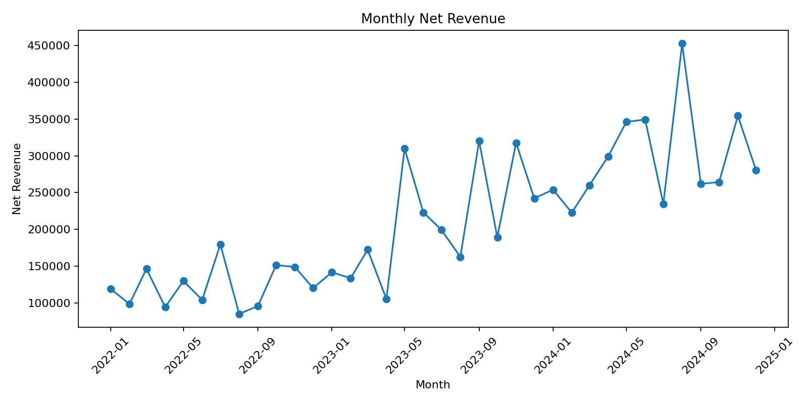

Business interpretation
The latest 24-month SQL results show substantial month-to-month volatility. The highest displayed month was 2024-08 at $454,886.62. Planning should therefore use ranges and moving averages.

6.2 Category revenue performance
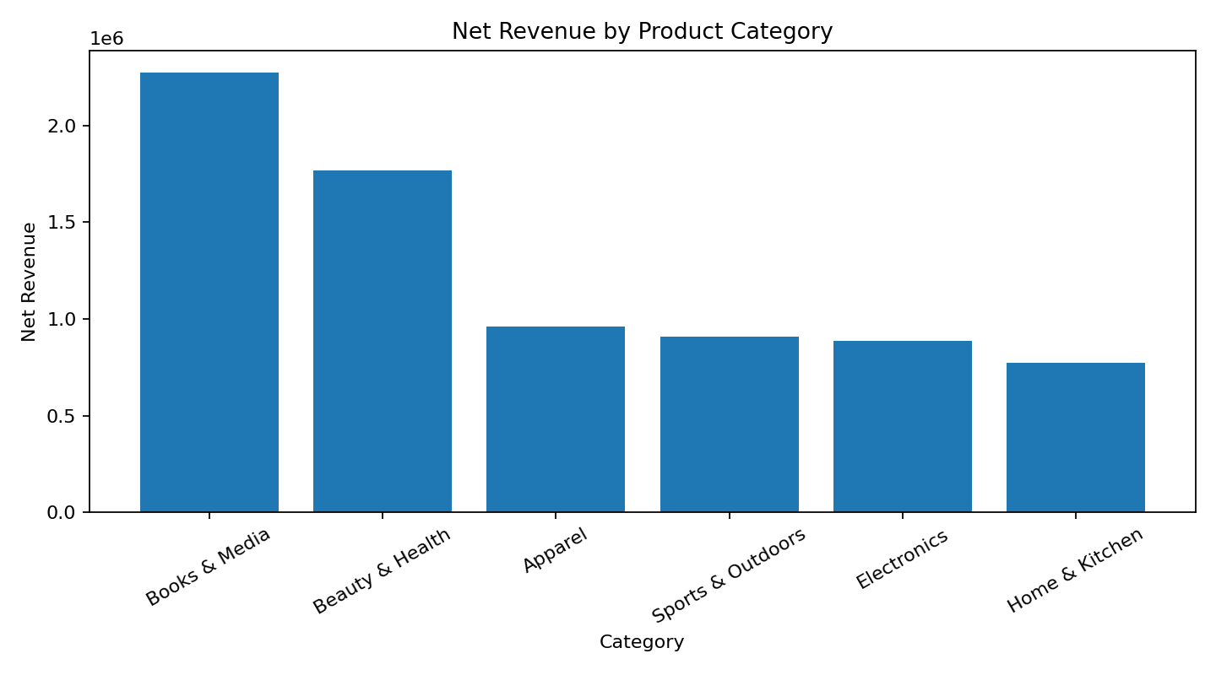

Business interpretation
Books & Media generated the highest category revenue at $2,288,541.26. Inventory protection and marketing support should prioritize this category while validating margin.

6.3 Category return rate
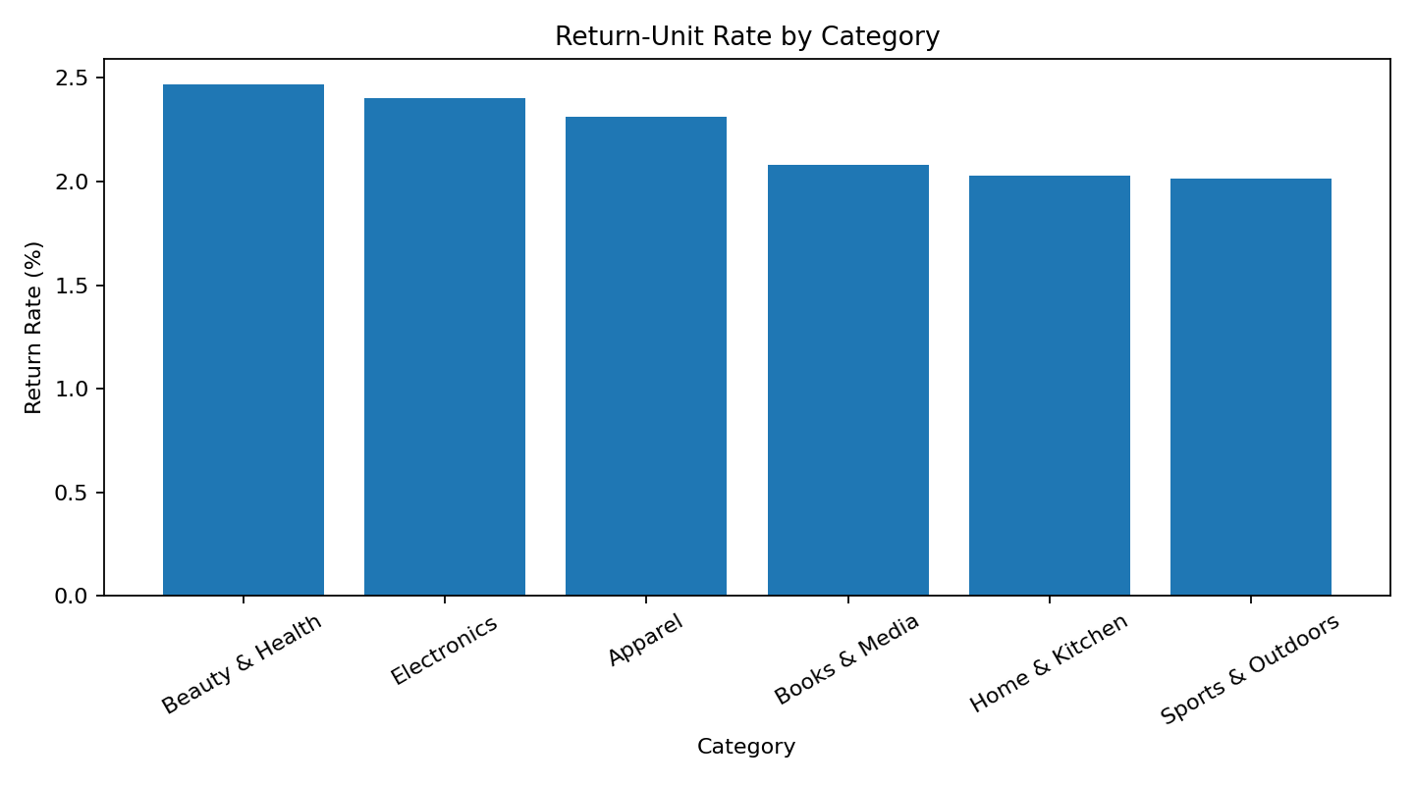

Business interpretation
Beauty & Health had the highest return-unit rate at 2.45%. Management should inspect product quality, descriptions, packaging, and supplier issues.

6.4 RFM segment revenue
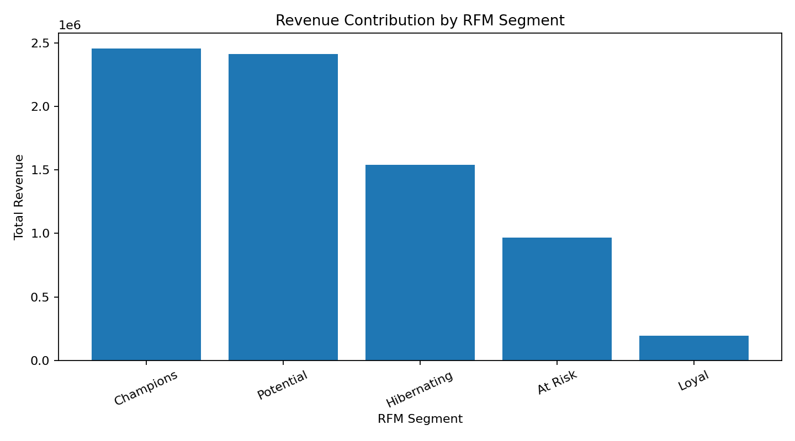

Business interpretation
Champions generated the largest segment revenue at $2,455,158.51. Retention investment should reflect both revenue contribution and churn risk.

6.5 Top products
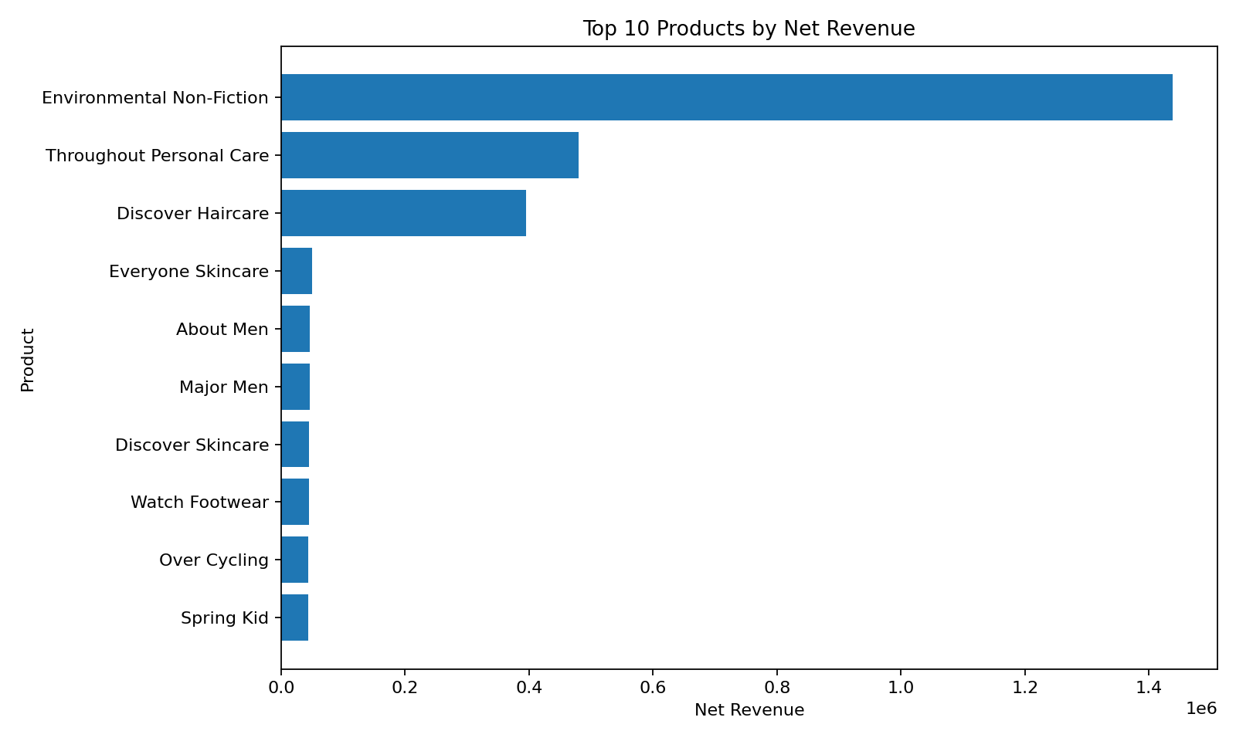

Business interpretation
Revenue is concentrated in a relatively small set of products. Replenishment and recommendation placement should protect these items, while return and margin performance are monitored.

6.6 Payment method by country
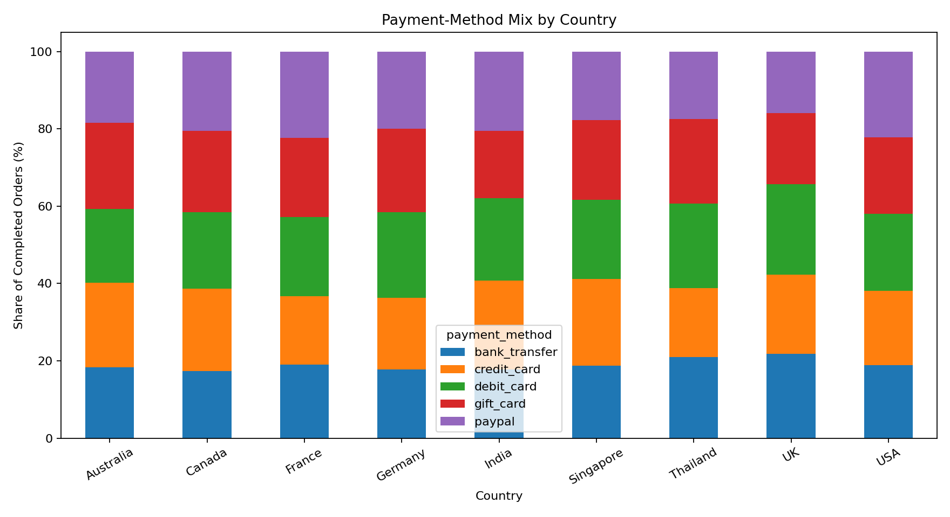

Business interpretation
Payment preferences vary across countries. Localized checkout ordering and provider coverage can reduce abandonment and improve conversion.

6.7 Ratings and repeat purchases
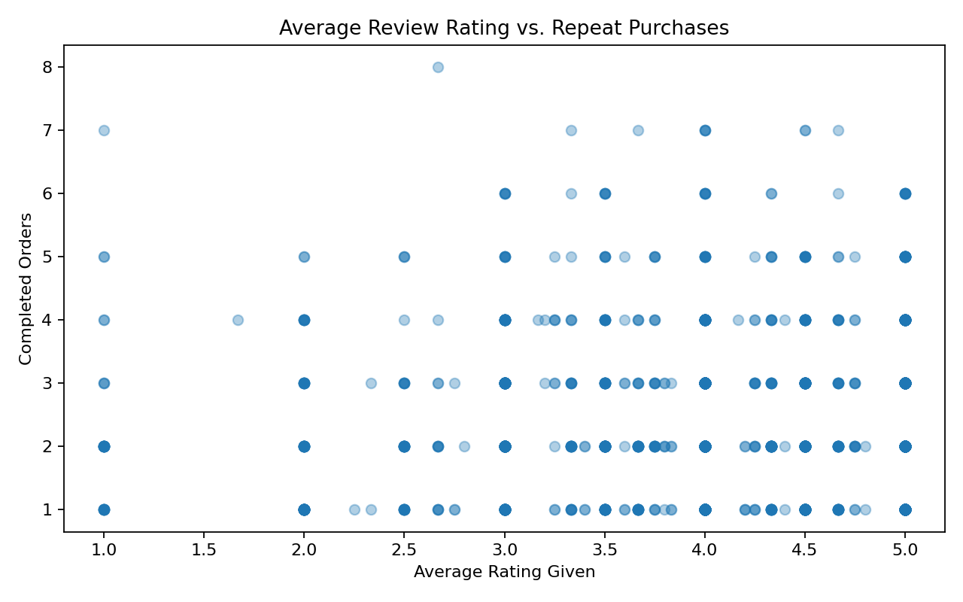

Business interpretation
The Pearson correlation between average rating given and completed orders is 0.035. This weak relationship means loyalty models should include recency, frequency, value, and engagement.

6.8 Weekly customer activity and revenue
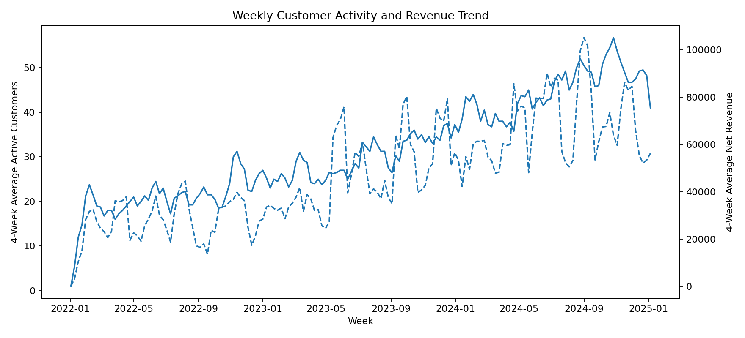

Business interpretation
Four-week moving averages reveal whether engagement and revenue move together. Divergence can indicate changing order value, discounting, product mix, or customer quality.

7. Limitations and Threats to Validity
- The data is fictional and may not capture every operational process found in a real retailer.
- Negative quantity is assumed to represent a return; no separate return reason or refund table is available.
- Outlier capping reduces influence but may alter legitimately premium product prices.
- Median age imputation reduces missingness but understates uncertainty and distribution variability.
- The regression model is descriptive and depends on the stability of historical relationships.
- Monte Carlo paths sample historical growth behavior and do not model future structural changes.
- Supplier-only products lack historical orders, preventing direct demand validation.
- Correlation does not establish causation between review behavior and repeat purchasing.

8. Recommendations and Next Steps

1. Protect high-value demand
Use category and product rankings to prioritize replenishment, but add margin and return-rate controls before committing inventory.

2. Establish segmented retention
Build separate campaigns for Champions, Loyal, At Risk, and high-value churn-risk customers.

3. Reduce return drivers
Review high-return categories at SKU and supplier level, including quality, sizing, descriptions, and packaging.

4. Govern the product master
Create ownership, matching rules, and exception queues for supplier-only and database-only SKUs.

5. Operationalize forecast ranges
Use regression and Monte Carlo outputs as planning ranges with monthly recalibration.

9. Reusable Pipeline
Phase 5 packages Phases 1-4 into a one-command driver. Running python main.py validates the raw inputs, executes analysis.ipynb, and regenerates clean datasets, SQL tables, NumPy model results, and charts. A Makefile provides install, run, and clean targets.

Commands
python -m pip install -r requirements.txt
python main.py
make run

GitHub repository structure
UrbanCart_Complete_Project/
├── analysis.ipynb
├── queries.sql
├── main.py
├── Makefile
├── requirements.txt
├── README.md
├── src/pipeline.py
├── data/raw/
├── data/processed/
└── outputs/{tables,model_results,charts}/

Appendix A - SQL Listing

SQL listing - Part 1
-- ============================================================
-- UrbanCart Big Data Analytics
-- Phase 1: SQL Data Extraction
-- Database: SQLite (ecommerce.db)
-- ============================================================
-- Query 1: Calculate net revenue, order count, and average order
-- value by product category after accounting for discounts.
SELECT
p.category,
ROUND(
SUM(
oi.quantity
* oi.unit_price
* (1 - COALESCE(oi.discount, 0))
),
2
) AS total_revenue,
COUNT(DISTINCT o.order_id) AS total_orders,
ROUND(
SUM(
oi.quantity
* oi.unit_price
* (1 - COALESCE(oi.discount, 0))
) / NULLIF(COUNT(DISTINCT o.order_id), 0),
2
) AS average_order_value
FROM order_items AS oi
JOIN products AS p
ON oi.product_id = p.product_id
JOIN orders AS o
ON oi.order_id = o.order_id
WHERE LOWER(o.status) = 'completed'
GROUP BY p.category
ORDER BY total_revenue DESC;
-- ============================================================
-- Query 2: Identify the top 20 customers by lifetime spending,
-- including their city and signup date.
SELECT
c.customer_id,
c.name,
c.city,
c.signup_date,
COUNT(DISTINCT o.order_id) AS total_orders,
ROUND(
SUM(
oi.quantity
* oi.unit_price
* (1 - COALESCE(oi.discount, 0))
),
2
) AS lifetime_spending
FROM customers AS c
JOIN orders AS o
ON c.customer_id = o.customer_id
JOIN order_items AS oi
ON o.order_id = oi.order_id
WHERE LOWER(o.status) = 'completed'
GROUP BY
c.customer_id,
c.name,
c.city,
c.signup_date
ORDER BY lifetime_spending DESC
LIMIT 20;
-- ============================================================
-- Query 3: Show the month-over-month revenue trend for the most
-- recent 24 months, including previous revenue and percentage change.
WITH monthly_revenue AS (
SELECT
STRFTIME('%Y-%m', o.order_date) AS revenue_month,
ROUND(
SUM(
oi.quantity
* oi.unit_price
* (1 - COALESCE(oi.discount, 0))
),
2
) AS revenue
FROM orders AS o
JOIN order_items AS oi
ON o.order_id = oi.order_id
WHERE LOWER(o.status) = 'completed'
GROUP BY STRFTIME('%Y-%m', o.order_date)
),
recent_24_months AS (
SELECT
revenue_month,
revenue
FROM monthly_revenue
ORDER BY revenue_month DESC
LIMIT 24
),
monthly_comparison AS (
SELECT
revenue_month,
revenue,
LAG(revenue) OVER (
ORDER BY revenue_month
) AS previous_month_revenue
FROM recent_24_months
)
SELECT
revenue_month,
revenue,
previous_month_revenue,
ROUND(
revenue - previous_month_revenue,
2
) AS revenue_change,
ROUND(
100.0 * (revenue - previous_month_revenue)
/ NULLIF(previous_month_revenue, 0),
2
) AS percentage_change
FROM monthly_comparison
ORDER BY revenue_month;
-- ============================================================
-- Query 4: Calculate the return rate for each category. Negative
-- quantities represent returned units.
WITH category_item_summary AS (
SELECT
p.category,
COUNT(*) AS total_item_rows,
SUM(
CASE
WHEN oi.quantity < 0 THEN 1
ELSE 0
END
) AS returned_item_rows,
SUM(ABS(oi.quantity)) AS total_units,
SUM(
CASE
WHEN oi.quantity < 0 THEN ABS(oi.quantity)
ELSE 0
END
) AS returned_units
FROM order_items AS oi
JOIN products AS p
ON oi.product_id = p.product_id
GROUP BY p.category
)
SELECT
category,
total_item_rows,
returned_item_rows,
returned_units,
total_units,
ROUND(
100.0 * returned_item_rows
/ NULLIF(total_item_rows, 0),
2
) AS return_row_rate_percent,
ROUND(
100.0 * returned_units
/ NULLIF(total_units, 0),
2
) AS return_unit_rate_percent
FROM category_item_summary
ORDER BY return_unit_rate_percent DESC;
-- ============================================================
-- Query 5: Find customers who placed at least one completed order
-- in every one of the latest three calendar quarters in the data.
WITH latest_date AS (
SELECT

SQL listing - Part 2
MAX(DATE(order_date)) AS maximum_order_date
FROM orders
),
latest_quarter AS (
SELECT
DATE(
STRFTIME('%Y', maximum_order_date)
|| '-'
|| PRINTF(
'%02d',
(
(
CAST(STRFTIME('%m', maximum_order_date) AS INTEGER)
- 1
) / 3
) * 3 + 1
)
|| '-01'
) AS current_quarter_start
FROM latest_date
),
required_quarters AS (
SELECT current_quarter_start AS quarter_start
FROM latest_quarter
UNION ALL
SELECT DATE(current_quarter_start, '-3 months')
FROM latest_quarter
UNION ALL
SELECT DATE(current_quarter_start, '-6 months')
FROM latest_quarter
),
customer_quarters AS (
SELECT DISTINCT
o.customer_id,
DATE(
STRFTIME('%Y', o.order_date)
|| '-'
|| PRINTF(
'%02d',
(
(
CAST(STRFTIME('%m', o.order_date) AS INTEGER)
- 1
) / 3
) * 3 + 1
)
|| '-01'
) AS quarter_start
FROM orders AS o
WHERE LOWER(o.status) = 'completed'
)
SELECT
c.customer_id,
c.name,
c.city,
c.signup_date,
COUNT(DISTINCT cq.quarter_start) AS active_required_quarters
FROM customers AS c
JOIN customer_quarters AS cq
ON c.customer_id = cq.customer_id
JOIN required_quarters AS rq
ON cq.quarter_start = rq.quarter_start
GROUP BY
c.customer_id,
c.name,
c.city,
c.signup_date
HAVING COUNT(DISTINCT cq.quarter_start) = 3
ORDER BY c.name;
-- ============================================================
-- Query 6: Return the 10 products with the highest valid average
-- review rating among products with at least 15 valid reviews.
SELECT
p.product_id,
p.name,
p.category,
COUNT(r.review_id) AS total_reviews,
ROUND(AVG(r.rating), 2) AS average_rating
FROM products AS p
JOIN reviews AS r
ON p.product_id = r.product_id
WHERE r.rating BETWEEN 1 AND 5
GROUP BY
p.product_id,
p.name,
p.category
HAVING COUNT(r.review_id) >= 15
ORDER BY
average_rating DESC,
total_reviews DESC,
p.name
LIMIT 10;
-- ============================================================
-- Query 7: Calculate average session duration and pages viewed by
-- device for customers who made at least one completed purchase.
SELECT
ws.device,
COUNT(*) AS total_sessions,
COUNT(DISTINCT ws.customer_id) AS purchasing_customers,
ROUND(AVG(ws.duration_minutes), 2) AS average_duration_minutes,
ROUND(AVG(ws.pages_viewed), 2) AS average_pages_viewed
FROM web_sessions AS ws
WHERE EXISTS (
SELECT 1
FROM orders AS o
WHERE o.customer_id = ws.customer_id
AND LOWER(o.status) = 'completed'
)
GROUP BY ws.device
ORDER BY average_duration_minutes DESC;
-- ============================================================
-- Query 8: Rank products by net revenue within each product category.
WITH product_revenue AS (
SELECT
p.category,
p.product_id,
p.name,
ROUND(
SUM(
oi.quantity
* oi.unit_price
* (1 - COALESCE(oi.discount, 0))
),
2
) AS net_revenue
FROM products AS p
JOIN order_items AS oi
ON p.product_id = oi.product_id
JOIN orders AS o
ON oi.order_id = o.order_id
WHERE LOWER(o.status) = 'completed'
GROUP BY
p.category,
p.product_id,
p.name
)
SELECT
category,
product_id,
name,
net_revenue,
DENSE_RANK() OVER (
PARTITION BY category
ORDER BY net_revenue DESC
) AS revenue_rank
FROM product_revenue
ORDER BY
category,
revenue_rank,
name;
-- ============================================================
-- Query 9: Show the payment-method mix by customer country as both
-- order count and percentage share of orders within each country.
WITH country_payment_orders AS (
SELECT
c.country,
o.payment_method,
COUNT(DISTINCT o.order_id) AS order_count
FROM customers AS c
JOIN orders AS o
ON c.customer_id = o.customer_id
WHERE LOWER(o.status) = 'completed'
GROUP BY
c.country,
o.payment_method
)
SELECT
country,
payment_method,
ord

SQL listing - Part 3
er_count,
ROUND(
100.0 * order_count
/ SUM(order_count) OVER (
PARTITION BY country
),
2
) AS payment_method_share_percent
FROM country_payment_orders
ORDER BY
country,
payment_method_share_percent DESC;
-- ============================================================
-- Query 10: Leadership should identify high-value customers who may
-- be at risk of churn so retention campaigns can be prioritized.
WITH customer_activity AS (
SELECT
c.customer_id,
c.name,
c.city,
c.country,
MAX(DATE(o.order_date)) AS last_order_date,
COUNT(DISTINCT o.order_id) AS completed_orders,
ROUND(
SUM(
oi.quantity
* oi.unit_price
* (1 - COALESCE(oi.discount, 0))
),
2
) AS lifetime_revenue
FROM customers AS c
JOIN orders AS o
ON c.customer_id = o.customer_id
JOIN order_items AS oi
ON o.order_id = oi.order_id
WHERE LOWER(o.status) = 'completed'
GROUP BY
c.customer_id,
c.name,
c.city,
c.country
),
dataset_reference_date AS (
SELECT MAX(DATE(order_date)) AS latest_order_date
FROM orders
)
SELECT
ca.customer_id,
ca.name,
ca.city,
ca.country,
ca.last_order_date,
CAST(
JULIANDAY(drd.latest_order_date)
- JULIANDAY(ca.last_order_date)
AS INTEGER
) AS days_since_last_order,
ca.completed_orders,
ca.lifetime_revenue,
CASE
WHEN ca.lifetime_revenue >= 5000
AND (
JULIANDAY(drd.latest_order_date)
- JULIANDAY(ca.last_order_date)
) >= 90
THEN 'High-value churn risk'
WHEN ca.lifetime_revenue >= 5000
THEN 'High-value active'
WHEN (
JULIANDAY(drd.latest_order_date)
- JULIANDAY(ca.last_order_date)
) >= 90
THEN 'Inactive'
ELSE 'Active'
END AS customer_status
FROM customer_activity AS ca
CROSS JOIN dataset_reference_date AS drd
ORDER BY
CASE customer_status
WHEN 'High-value churn risk' THEN 1
WHEN 'High-value active' THEN 2
WHEN 'Inactive' THEN 3
ELSE 4
END,
ca.lifetime_revenue DESC;

Appendix B - Data Dictionary
Table | Field | Meaning
customers | customer_id | Primary key
customers | signup_date | Customer registration date
products | unit_price | Listed product price
products | cost | Product cost
orders | status | completed / returned / cancelled / pending
order_items | quantity | Negative quantity represents return
order_items | discount | Fractional discount
reviews | rating | Valid range 1-5
web_sessions | duration_minutes | Session engagement

Individual contribution statement
This repository was prepared as an individual analytics project. The contributor reviewed the assignment requirements, organized the source files, wrote and validated all ten SQL queries, developed pandas cleaning and integration rules, implemented the four NumPy analytical routines, produced the eight business visualizations, documented business interpretations, and packaged the workflow as a reusable pipeline. The contributor also prepared the report, executive summary, README, processed datasets, audit tables, and GitHub-ready folder structure. Automated generation was used to improve consistency, but all transformations, assumptions, outputs, and conclusions were checked against the supplied data dictionary and project requirements.

